**PREFACE**

We are the students of **BCA[**sem-6**]** recognized by **Shri C. J. Patel College of Computer Studies Visnagar.** As a part of study we have done this project work, our project is **CODEWORK FREELANCER MANAGEMENT SYSTEM**. This has been a very important factor in growth of **FREELANCING SERVICES** and it provides better part time job.

It has been a rich variety of work in technically advanced environment of website development team, logo design and programming skills and to make project work better and faster.

**ACKNOWLEDGEMENT**

First of all, we thank to our parents and then we are thankful to Sankalchand Patel University for giving us an opportunity to develop the system secondly we are thankful to SHRI C. J. PATEL COLLEGE COMPUTER STUDIES, VISNAGAR to Provide the excellent environment to us for developing the project.

We are once again thankful to staff members who always gave their valuable and wonderful advice as well as time to us for developing the project.

Vivek D. Patel

Priya S. Patel

Gaurang J. Parmar

**NEED FOR NEW SYSTEM**

* Various freelancer can be find for different type of website developing and designing work.
* The current system its total manual. Client can post project and choose a best freelancer from all of list.
* Browse freelancer profiles, compare proposals and select the best one, award your project and your freelancer goes to work.
* Pay when you are satisfied!
* Codework has no access fees, subscriptions, monthly fees or annual fees. There are no fees to post a project or set up a user account. Employer commissions and upgrade fees are also waived for volume customers.

**HARDWARE & SOFTWERE REQUERMENT**

**HARDWARE REQUIREMENT**

* PROCESSOR : intel CORE i3
* RAM : 4GB
* HARD-DISK : 500GB
* WINDOWS : WINDOWS 7/8.1/10

**SOFTWARE REQUIREMENT**

* FRONT END TOOL : PHP 5.6.0
* BACK END TOOL : MySQL
* OTHER TOOLS : MS WORD 2016

MS POWERPOINT 2016

**CONTEX LEVEL DIAGRAM**

FREELANCER

Make Inquiry

Freelancer Details

Request For Project

Client Inquiry Details

Client Registration Details

Client Project Details

Freelancer Details

Client Information

Get Inquiry Reply

Success/Fail

View Client Project

Accept/Denied

Request For Project

Post Project

Client Details

Get Inquiry Reply

CLIENT

ADMIN

0.0

**FIRST LEVEL DIAGRAM FREELANCER**

FREELANCER

FREELANCER

v

Freelancer Feedback

Submitted

FEEDBACK

3.0

4.0

2.0

1.0

Request For Project

Project Request

Project Details

View Project

REQUEST_PRJ

POST_PRJ

Success & Fail

Registration

Registration Details

User ID & Password

Success & Fail

Log In Information

Registration Information

**FIRST LEVEL DIAGRAM ADMIN**

ADMIN

1.0

ADMIN

View Feedback

4.0

Accept/Denied

Manage freelancer

Users Details

3.0

Freelancer Registration details

Freelancer Registration

FREELANCER

2.0

Success & Fail

Success & Fail

Feedback Details

FEEDBACK

Manage Client

CLIENT

Log In

ID & Password

ID & Password

**FIRST LEVEL DIAGRAM CLIENT**

CLIENT

Registration

Feedback

Post

Log In

Project Request Verification

5.0

1.0

2.0

3.0

4.0

CLIENT

Success & Reject

Client Details

Client details

Success & Reject

POST_PRJ

Accept & Reject

Accept & Reject

Log In Details

ID & password

REQ_PRJ

Post Project

Project Details

Submit Feedback

FEEDBACK

Freelancer Request

Accept & Reject

Freelancer Request

Client Feedback

**E R DIAGRAM**

send

REQUEST PROJECT

has

1

M

M

1

has

CLIENT

FREELANCER

ADMINE

1

1

1

1

1

Post

POST PROJECT

M

submit

submit

view

M

M

M

FEEDBACK

M

**H R DIAGRAM**

FEEDBACK

FREELANCER

DETAILS

CLIENT

DETAILS

HOME

LOG IN

ADMIN

CLIENT

FEEDBACK

FREELANCER

LOG IN

RAGISTRATION

ABOUT

HOME

USER

CODEWORK FREELANCER MANAGEMENT SYSTEM

**DATA DICTIONARY**

1.Admin

|  |  |  |  |  |  |
| --- | --- | --- | --- | --- | --- |
| **Sr.No** | **Field Name** | **Type** | **Size** | **Constraints** | **Description** |
| 1 | id | Int | 11 | Primary key | Admin id |
| 2 | name | Varchar | 50 | Not null | Admin name |
| 3 | email | Varchar | 50 | Unique key | Admin email |
| 4 | password | Varchar | 32 | Not null | Admin password |
| 5 | date | Time stamp | - | Current timestamp | Date Update Records |

* **Description :-** Admin login information

2.Client

|  |  |  |  |  |  |
| --- | --- | --- | --- | --- | --- |
| **Sr.No** | **Field Name** | **Type** | **Size** | **Constraints** | **Description** |
| 1 | cid | Int | 11 | Primary key | client id |
| 2 | name | Varchar | 50 | Not null | client name |
| 3 | email | Varchar | 120 | Unique key | client email |
| 4 | password | Varchar | 128 | Not null | client password |
| 5 | date | Time stamp | - | Current timestamp | Client sign up Date |

* **Description :-**Client registration

3.Feedback

|  |  |  |  |  |  |
| --- | --- | --- | --- | --- | --- |
| **Sr.No** | **Field Name** | **Type** | **Size** | **Constraints** | **Description** |
| 1 | fbid | int | 11 | Primary key | Feedback id |
| 2 | name | Varchar | 30 | Not null | user name |
| 3 | email | Varchar | 50 | Unique key | user email |
| 4 | msg | Varchar | 255 | Not null | Feedback message |
| 5 | Is_read | Tinyint | 1 | Not null | Msg read or not |
| 6 | date | Time stamp | - | Current timestamp | Feedback Date |

* **Description :-**to save user feedback

4.freelancer

|  |  |  |  |  |  |
| --- | --- | --- | --- | --- | --- |
| **Sr.No** | **Field Name** | **Type** | **Size** | **Constraints** | **Description** |
| 1 | fid | Int | 11 | Primary key | freelancer id |
| 2 | name | Varchar | 30 | Not null | freelance name |
| 3 | email | Varchar | 50 | Unique key | freelance email |
| 4 | password | Varchar | 32 | Not null | freelancer password |
| 5 | lang | Varchar | 10 | Not null | Programming language |
| 6 | cv | Varchar | 50 | Not null | Freelancer resume |
| 7 | Id_proof | Varchar | 50 | Not null | Freelancer  Id/proof |
| 8 | date | Time stamp | - | Current timestamp | Freelancer Sign up Date |

* **Description :-** freelancer registration

5.post_prj

|  |  |  |  |  |  |
| --- | --- | --- | --- | --- | --- |
| **Sr.No** | **Field Name** | **Type** | **Size** | **Constraints** | **Description** |
| 1 | pid | Int | 11 | Primary key | Project id |
| 2 | name | Varchar | 30 | Not null | Project name |
| 3 | detail | Text | - | Not null | Project detail |
| 4 | catagory | Varchar | 30 | Not null | Project catagory |
| 5 | file | varchar | 255 | Not null | Browse project file |
| 4 | lang | Varchar | 20 | Not null | programming language |
| 5 | cid | Int | 11 | Not null | Client id |
| 6 | fid | Int | 11 | Not null | Freelancer id |
| 7 | status | Varchar | 20 | Not null | Project status |
| 8 | cost | Int | 11 | Not null | Project cost |
| 9 | Paid | int | 11 | Nott null | Project paid |
| 10 | date | Time stamp | - | Current timestamp | Project Date |

* **Description :-**post project details

6.post_req

|  |  |  |  |  |  |
| --- | --- | --- | --- | --- | --- |
| **Sr.No** | **Field Name** | **Type** | **Size** | **Constraints** | **Description** |
| 1 | rid | Int | 11 | Primary key | Request id |
| 2 | pid | Int | 11 | Not null | Project id |
| 3 | fid | Int | 11 | Not null | Freelancer id |
| 4 | msg | Varchar | 255 | Not null | Message |
| 5 | status | Varchar | 20 | Not null | Project status |
| 6 | date | Time stamp | - | Current timestamp | Project Request date |

* **Description :-**project request

**FROM DESIGN**

1.Home page



* **Description** :This page is home page

2.Registration page

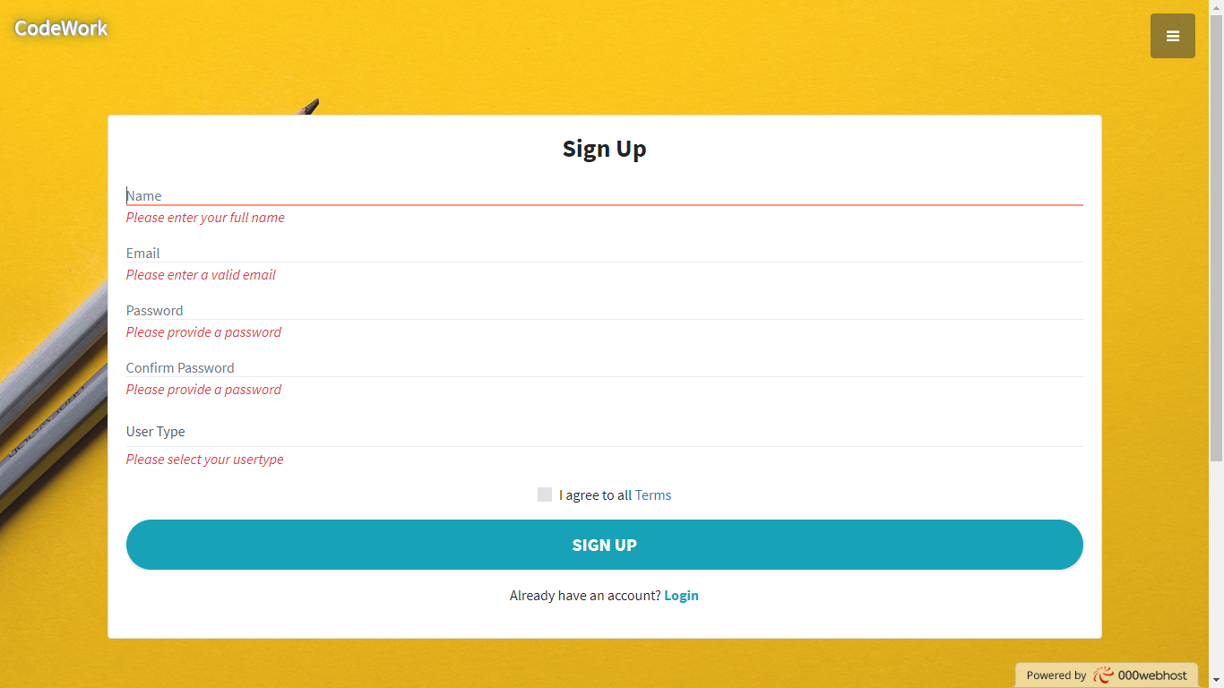

* **Description** :-This page is registration page

3.freelancer registration page

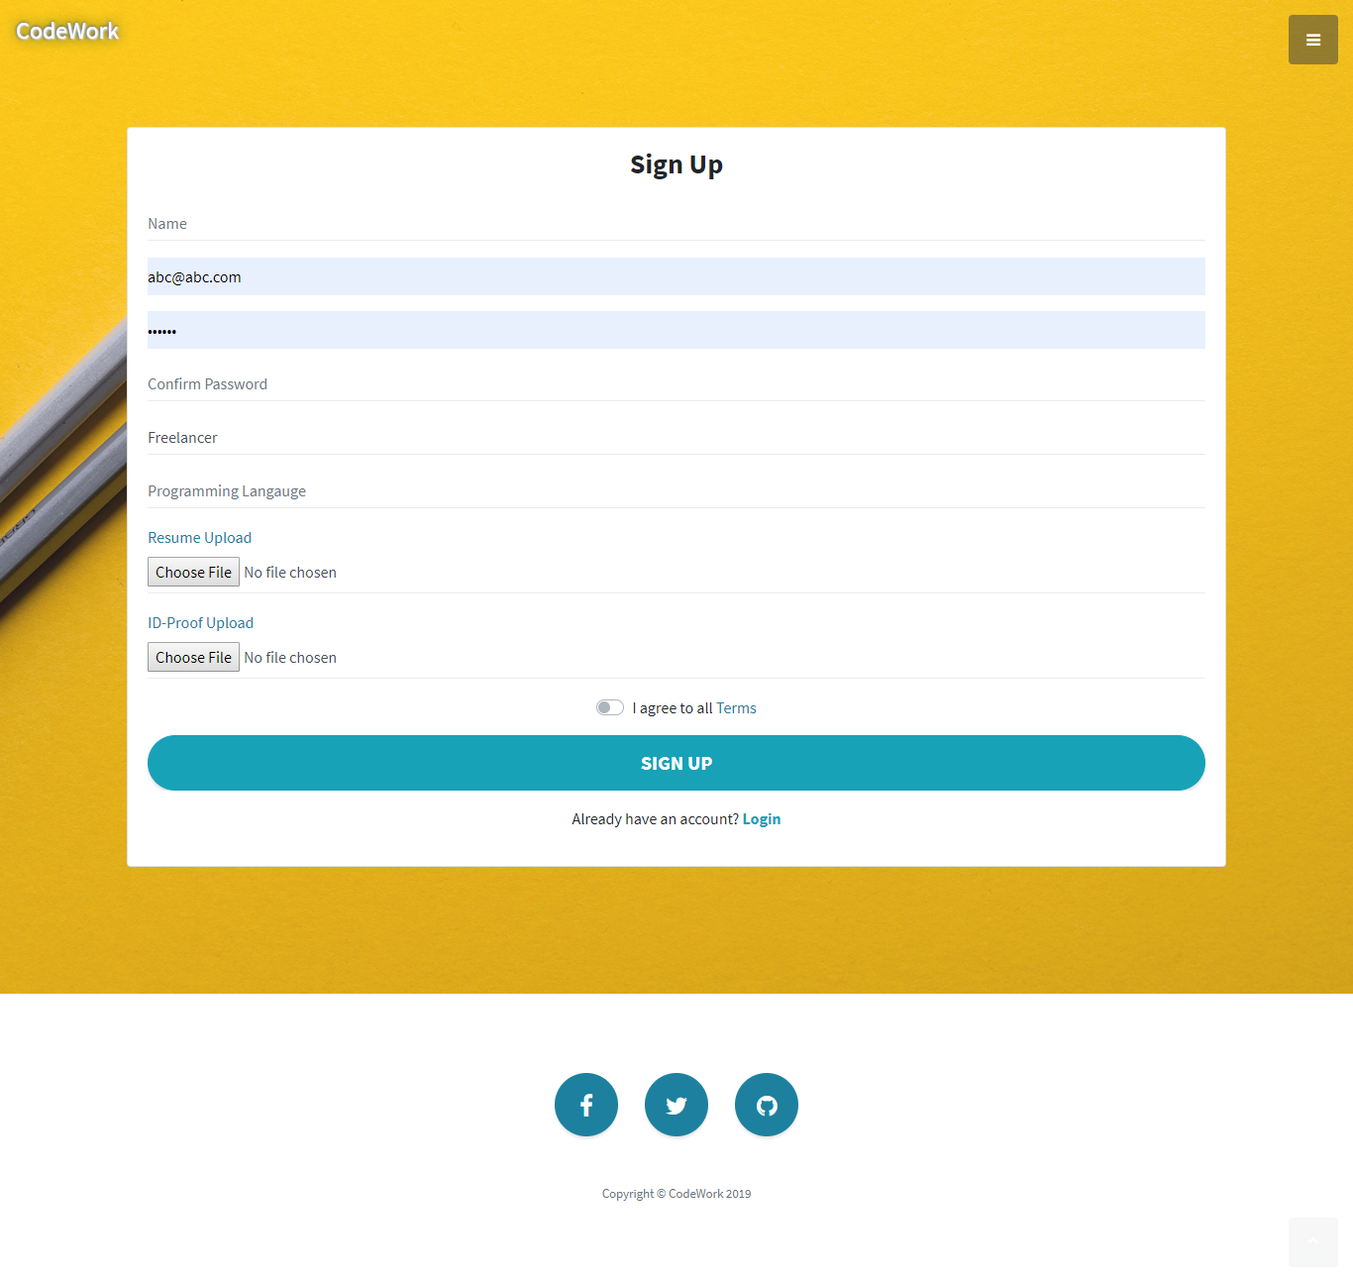

* **Description** :-This page is freelancer registration page

4.Login page

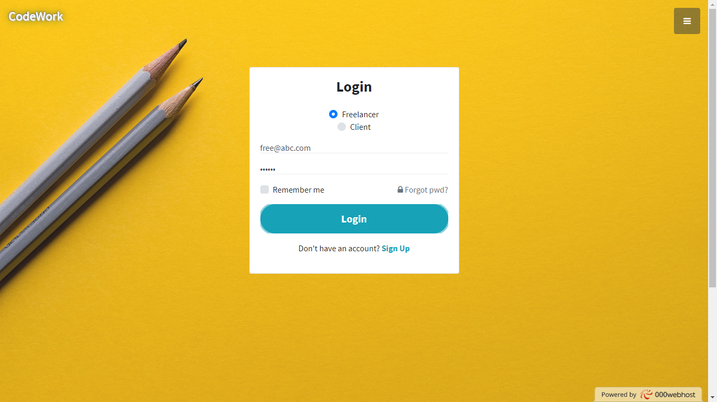

* **Description** :-This page is Login page

4.Admin Login page



* Description :-This page is admin Login page

5.Admin Login page